AM000-Asia-China-Tang-Mirror-Seven Arc

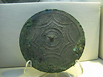

[RARE CHINESE BRONZE MIRROR](http://www.ebay.com/itm/251023137458?ssPageName=STRK:MEWNX:IT&_trksid=p3984.m1439.l2649) (251023137458)

Sale date: 05/03/12

Tracking number: --

Estimated Delivery: 05/21/12 - 06/04/12

$399.00

Free

shipping